1 | Executive Summary

This report is built on transactional and behavioral data from 3,900 customers of a D2C fashion brand operating across the United States. Using Python for feature engineering, PostgreSQL for customer segmentation analysis, and a structured two-definition loyalty framework, we answer five core business questions and translate findings into two actionable outputs, a Promotional Sunset Plan and an Ideal Customer Profile. The analysis reveals three critical findings: First, 43% of the brand's customer base buys exclusively on discounts, meaning the brand is not building loyalty but renting attention through continuous promotional activity.

________________________________________________________________________________
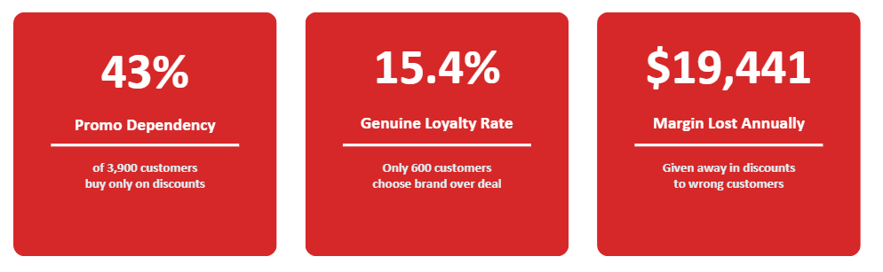
Core Problems :

- First, 43% of the brand's customer base buys exclusively on discounts which means the brand is not building loyalty but renting attention through continuous promotional activity.
- Second, only 600 customers (15.4%) qualify as genuinely loyal under our behavioural loyalty definition (Loyal_A), customers who have a long purchase history, never used a discount, and are satisfied with the brand.
- Third, $19,441 in estimated margin is being given away annually in discounts, predominantly to the segments that spend the least and are least likely to stay.
______________________________________________________________________________

The central question this report answers:

"Is the business successfully building a loyal customer base, or is it reliant on continuous promotional activity?"

The answer is clear and the path forward is outlined in the four recommendations that follow.

2 | Customer Landscape

The brand's 3,900 customers are divided into five behaviorally distinct segments, engineered from nine customer-level metrics built during the feature engineering phase.
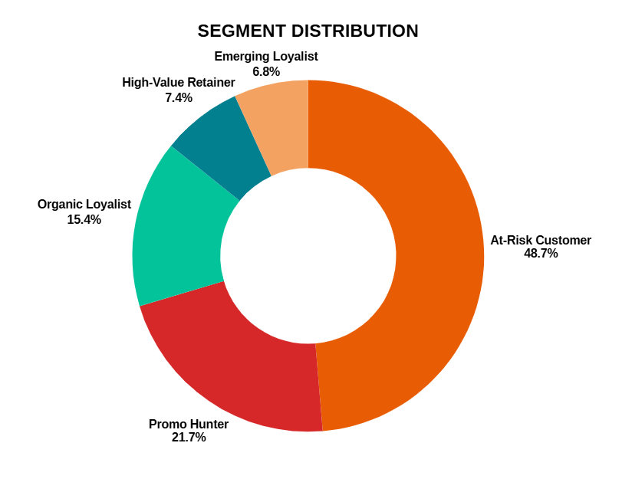

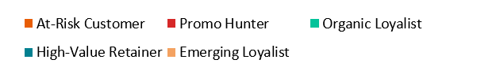

The distribution reveals a structurally weak loyalty base.
- Nearly 49% of customers fall into the At-Risk segment ( a large, heterogeneous group with mixed promo dependency and uncertain future purchase behavior).
- Promo Hunters make up another 21.7%
This shows that the total discount-dependent or at-risk population is over 70% of the customer base.
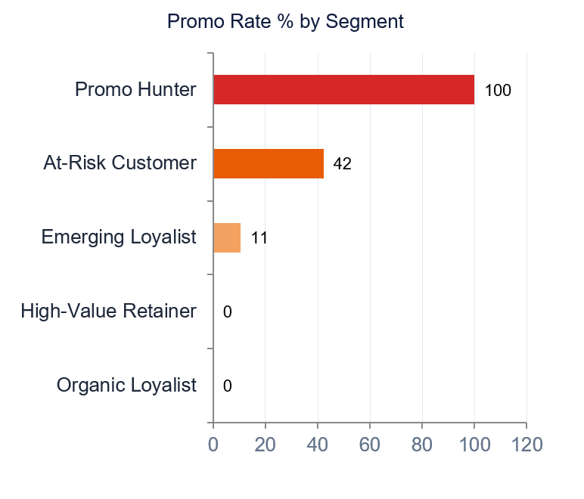

The promo rate chart makes the contrast stark.
- Organic Loyalists and High-Value Retainers show 0% promo dependency which means they buy at full price consistently.
- Promo Hunters show 100% promo dependency implying every single purchase in their history was made on a discount.
- At-Risk customers sit in between at 42.3%, making them the most complex segment to address.

The loyal core : Organic Loyalists and High-Value Retainers combinedly represents only 22.8% of the customer base. This is the brand's most valuable asset and its most underdeveloped opportunity.

3 | KEY FINDING 01 - Genuine Loyal Customers vs Discount Buyers

The most fundamental question this analysis set out to answer was whether the brand's customers are genuinely loyal or simply discount dependent. To answer this rigorously, we constructed two competing loyalty definitions and tested both against the data.

Loyal_A (Behavioural Definition): A customer is classified as loyal if they have at least 25 previous purchases(avg of previous purchases is 25,so we considered that as standard for this), have never used a promotional discount, and have a review rating of 3.8(average review rating) or above. This definition captures customers who return to the brand on their own terms without needing an incentive.

Loyal_B (Revenue-Based Definition): A customer is classified as loyal if they hold an active subscription, spend above $60(median spend) per transaction, and have a value score above 0.450(0.45 was chosen as it sits
just above the mean value_score of the dataset (mean = 0.4468, median = 0.4331)).
This definition attempts to capture loyalty through spending behavior and subscription commitment.
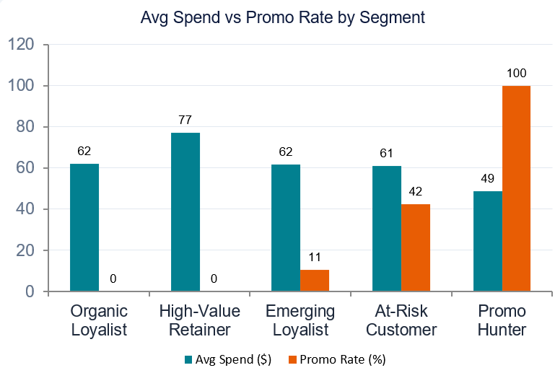

The chart reveals a clear contrast.
- Organic Loyalists, all of whom qualify under Loyal_A show zero promo dependency and a strong average spend of $62.
- Promo Hunters show 100% promo dependency and the lowest average spend of $48 in the entire dataset.

Critically, when we tested Loyal_B, all 343 customers who qualified under this definition were found inside the At-Risk segment with a 100% promo rate.
This describes the original Loyal_B definition - tested and rejected precisely because of this finding.

This proves that revenue and subscription-based loyalty is misleading. Customers who spend above $60 and hold subscriptions are still entirely discount dependent.
Conclusion : Loyal_A is the correct definition and people under this category are Genuine Loyal Customers
Note: High-Value Retainers show $77 average spend and 0% promo rate which are stronger numbers than Organic Loyalists on both metrics. However they do not qualify as Loyal_A because they failed to meet at least one of the three conditions simultaneously, most likely a shorter purchase history or lower satisfaction score. They remain the brand's second most valuable segment and should be treated accordingly.

4 | KEY FINDING 02 - Behavioral Patterns That Predict High Customer Value

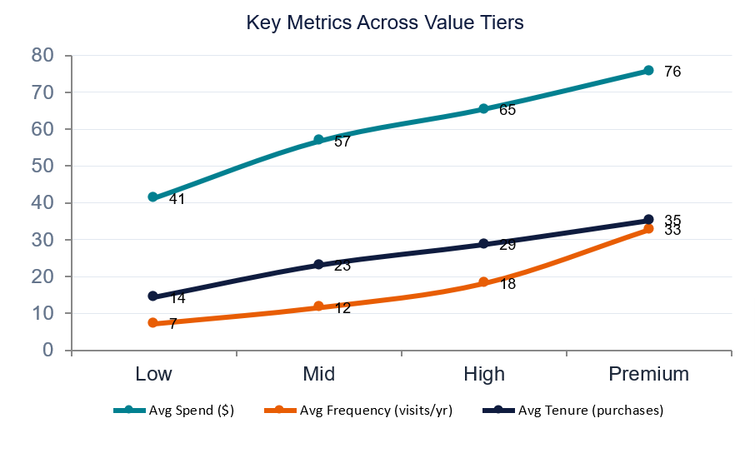
To understand what separates high-value customers from low-value ones, we analysed behavioral metrics across four value tiers - Low, Mid, High, and Premium which were constructed using a composite value score built from normalised spend, purchase frequency, and purchase history.

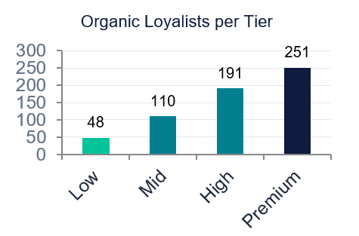

Three signals consistently increase as tier rises:
- Average spend grows from $41 in the Low tier to $76 in the Premium tier —> an 84% increase.
- Average purchase frequency grows from 7.2 visits per year to 32.8 —> 4.5x difference.
- Average tenure grows from 14.4 previous purchases to 35.2 —> 2.4x difference.

Conclusion :
The concentration of Organic Loyalists also increases with tier from 48 in the Low tier to 251 in the Premium tier. This confirms that genuine loyalty and high value are strongly correlated.
Note :
- However the most important finding from this analysis is what does NOT change across tiers. Promo rate stays virtually flat at approximately 43% across all four tiers. Even Premium customers, the brand's highest spenders with the longest purchase history use discounts at the same rate as Low tier customers.
- This is a brand-wide structural problem, not a segment-specific one. It means the brand cannot rely on the value tier alone to identify who to stop discounting. Frequency and tenure are the true predictors of customer value ,not spend and not promo behavior in isolation.

5 | KEY FINDING 03 - Geographies and Demographics That Are Underlevered

PART - A : Geographies That Are Underlevered

To identify underlevered states, we calculated a lift for each state on two dimensions relative to national averages (overall organic loyalist rate = 15.4%, overall promo rate = 43.0%) :
- loyalist_lift = state's loyalist rate ÷ 15.4%
- promo_lift = state's promo rate ÷ 43.0%
States were then classified as Organic Demand, Discount Driven, or Mixed.
________________________________________________________________________________

Organic Demand - 8 states (616 customers, $2,740 discount cost) : Alaska leads on both dimensions, with 53% more loyalists than the national rate and the highest average spend ($67.60) in the dataset. Kansas has the lowest promo rate in the country (23.8%) but the lowest average spend among this group ($54.56). Its loyalty is real but not yet commercially valuable.

Discount Driven - 4 states (315 customers, $1,970 discount cost) : Indiana has the highest promo reliance in the dataset (33% above the national average) with below-average loyalty. Missouri and West Virginia both sit at 0.64 loyalist lift (two-thirds the national loyalty rate) despite West Virginia having a relatively high average spend ($63.88), meaning its higher-spending customers are disproportionately discount-dependent.

Mixed - 38 states (2,969 customers, $15,172 discount cost) : This group accounts for 76% of all customers and 78% of total geographic discount spend, but no individual state shows an extreme signal. Pennsylvania ($66.57 spend, loyalist lift 1.23) and Connecticut (loyalist lift 1.16) sit just outside the Organic Demand cutoff (the closest near misses).

Conclusion:
- Alaska is the clearest organic demand market with high loyalty AND high spend.
- Kansas represents untapped potential with loyal but low value.
- Indiana, Missouri and West Virginia should be treated cautiously for acquisition spend.
________________________________________________________________________________

PART - B : Demographics That Are Underlevered
Spend (~$59-60) and promo rate (42-45%) are flat across age bands. So age isn't a strong big differentiator.
- 36-50 Prime Earners has the lowest promo rate (41.8%) and most loyalists (172), but it's also the largest group, so size explains most of this.
- 18-24 has the fewest loyalists (68) despite the highest rating (3.81), satisfied but not yet converted to loyal behavior.
Conclusion:
- Age is a weak lever overall. 18-24 is worth a loyalty nudge rather than a discount.
- Note : 36-50 leads in raw loyalist count (172) due to its larger segment size; 18-24 has the lowest loyalist rate despite the highest satisfaction score in the dataset.

6 | KEY FINDING 04 - Where the Margin Is Getting Lost

The brand estimates $19,882 in annual margin loss from promotional discounts in which $19,441 is lost to wrong customers (At-Risk + Promo-Hunter excl. Emerging Loyalist) , assuming a 20% average discount depth across all promo purchases. This assumption is conservative for a D2C fashion brand and serves as a floor estimate for the actual margin impact.
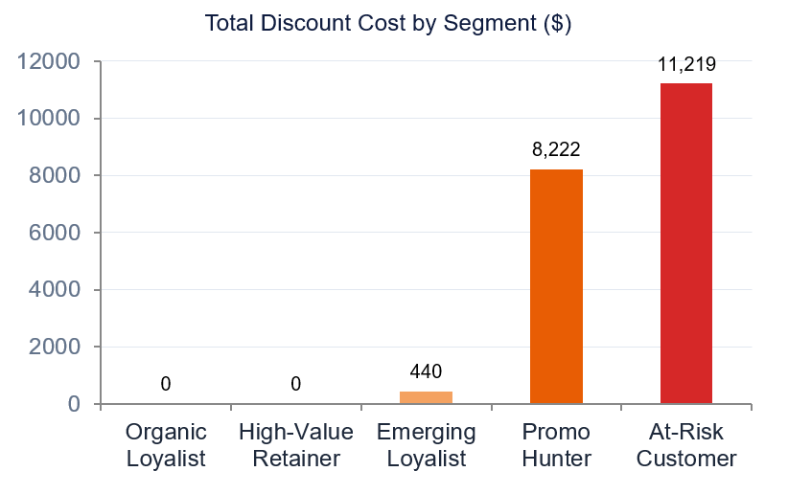

- The At-Risk segment is the largest absolute drain at $11,219, representing 9.7% of their total revenue given away as discounts.
- The Promo Hunter segment shows the worst ratio which is 20% of their entire revenue is given away in discounts despite their average spend being only $48, the lowest in the dataset.
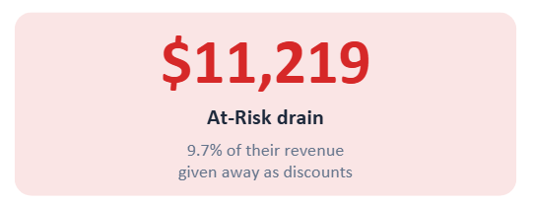
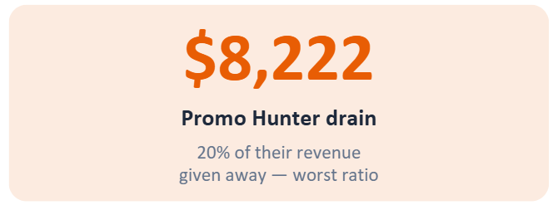
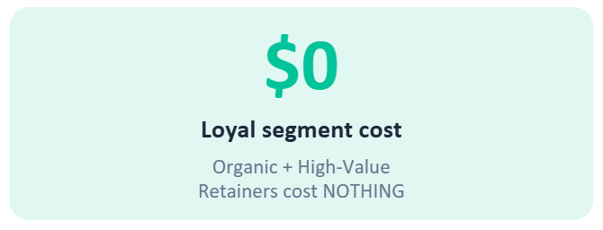

The most striking insight is the contrast at the extremes.
- Organic Loyalists and High-Value Retainers (888 customers) combined generate $59,376 in clean, full-price revenue with zero discount cost.
- Promo Hunters (846 customers) generate only $41,116 in gross revenue but require $8,222 in discounts to do so, yielding a net of $32,894.

Conclusion :
The brand is discounting its cheapest customers the most. Promo Hunters spend $14 less per transaction than Organic Loyalists but cost $8,222 in annual discounts. The brand is effectively subsidising its worst customers while its best customers require no subsidy at all.

7 | KEY FINDING 05 - The Brand's Ideal Customer Profile

Based on the 600 customers who qualify as Organic Loyalists under our Loyal_A definition, we can construct a data-backed description of the brand's most valuable customer which is specific enough for a marketing team to use for targeting decisions today.
________________________________________________________________________________

According to the key findings from SQL,
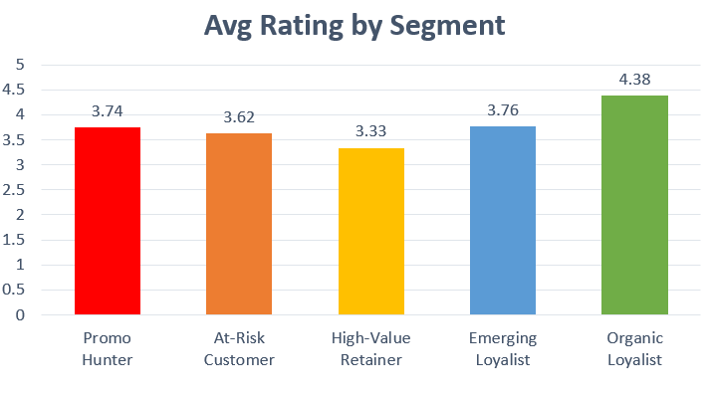
The ideal customer is aged between 36 and 50, falls in the Prime Earners life stage, and is most concentrated in Arizona, Kansas, and Connecticut. They have an average of 37.5 previous purchases, significantly above the dataset average of 25 and spend $62 per transaction. They have never used a promotional discount and give the brand an average rating of 4.38 out of 5, the highest satisfaction score in the entire dataset.

The rating chart makes the loyalty signal unmistakable. Organic Loyalists rate the brand 4.38 on average which is 0.63 points above the overall dataset average of 3.75 and significantly above every other segment. This is not a coincidence. Customers who return without needing a discount are customers who genuinely value what the brand offers.
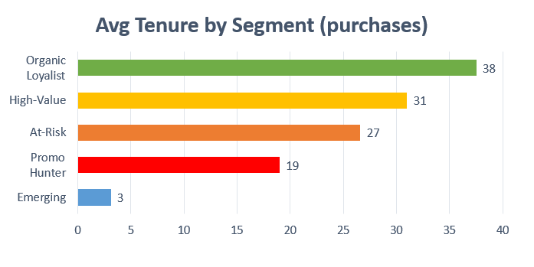

Conclusion :
The tenure chart reinforces this. With 37.5 average previous purchases, Organic Loyalists have been with the brand nearly twice as long as At-Risk customers (26.6) and nearly double High-Value Retainers (31.0). Their preferred categories are Clothing and Accessories, and their strongest seasons are Winter and Fall, the same season-category combinations that our SQL analysis identified as having the highest tenure and lowest promo rates.
________________________________________________________________________________

For every customer attribute : gender, subscription status, category, payment method, shipping type we compared the loyalist rate within that group vs the overall loyalist rate (15.4%).
This is called lift :
Lift > 1 means the group has MORE loyalists than average
Lift = 1 means no signal
Lift < 1 means FEWER loyalists than average.

Category, payment method, and shipping type : ALL show lift between 0.90 and 1.13 which essentially have no big signal. None of these attributes meaningfully predict loyalty.

Gender : Female customers have a 1.65x lift (25.4% loyalist rate vs 10.7% for males). Gender is the strongest predictor of loyalty in the entire dataset. However females are only 1,248 of 3,900 customers (32%), a small base with a strong signal

Subscription : The most surprising finding. Customers WITHOUT a subscription have a 21.1% loyalist rate (1.37x lift). Customers WITH a subscription have a 0.0% loyalist rate (0.00x lift) which means literally zero loyal customers out of 1,053 subscribers.

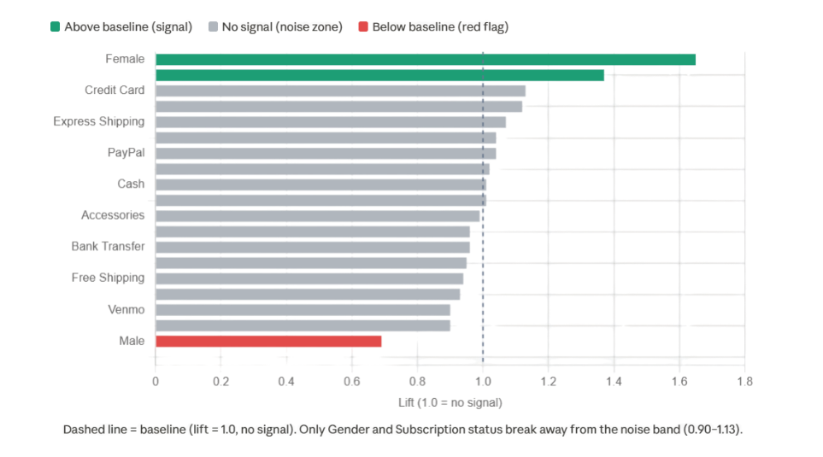

Season : Season shows no meaningful pattern among Organic Loyalists as the purchases are almost perfectly distributed across all four seasons (Summer 25.7%, Winter 25.3%, Fall 24.5%, Spring 24.5%). Since no season dominates, it is not a reliable attribute for identifying or targeting ideal customers.
Payment Method : Payment method is similarly flat as the Credit Card leads slightly at 19.5% followed by PayPal (18.0%), Cash (17.3%), Debit Card (15.5%) and Bank Transfer (15.0%). The differences are too small to be actionable. Including payment method in the ideal profile would overstate its importance.

Frequency : Purchase frequency shows no signal. Lift across all five categories (Weekly, Fortnightly, Monthly, Quarterly, Annually) ranges from only 0.94 to 1.12 relative to the baseline loyalist rate well within the noise band seen for category, payment method, and shipping type. Quarterly and Fortnightly buyers appear most often among Organic Loyalists in raw counts, but this simply reflects that they're the two largest frequency groups in the dataset overall (1,147 and 1,089 customers respectively), not a sign of higher loyalty. Frequency alone does not distinguish a loyal customer from a non-loyal one.

Conclusion :
These three attributes : season, frequency, and payment method were tested and found to carry no meaningful predictive signal for loyalty. They are excluded from the Ideal Customer Profile to keep every row in the table genuinely defensible and data-backed.

Conclusion :
- The subscription program is a product design failure, not a targeting problem, a 0.00 lift on a program meant to drive loyalty means it actively fails at its purpose. It must be rebuilt around non-discount value (early access, styling perks) before any acquisition spend goes toward it.
- Female customers are the strongest acquisition lever available (1.65x lift). Growing this 32% segment compounds directly into overall loyalist rate.

The Brand's Ideal Customer Profile

AGE | 36-50 (Prime Earners) - 172 out of 600 loyalists
GENDER | Female - 52.8% of all Organic Loyalists
SUBSCRIPTION | No active subscription - 100% of loyalists are non-subscribers (absolute finding)
LOCATION | Alaska (23.6% loyalist rate, highest nationally)  Alabama (22.5%) · Georgia (21.5%) · Montana (20.8%)  Note: Alabama & Montana have highest raw loyalist counts (20 each) due to larger customer bases.
PREV PURCHASES | 37.5 (dataset avg : 25)
AVG SPEND | $62 per transaction
PROMO RATE | 0% - never used a discount
AVG RATING | 4.38/5.0
CATEGORY | Clothing (45%) . Accessories (31%) - 76% of loyalists
BEST SEASON | Winter . Fall

8 | RECOMMENDATIONS

8.1 | RECOMMENDATION - 01 : STOP Discounting Promo Hunters ( Immediately )

Promo Hunters are 846 customers with a 100% promotional purchase rate, $48 average spend (the lowest in the dataset) and $8,222 in annual margin drain representing 20% of their total revenue given away as discounts. Every single purchase in their history was made on a discount. These customers did not choose the brand, they chose the deal.

Trigger Behavior : Any customer with three or more consecutive promotional purchases and zero full price purchases in their entire purchase history.

Action :
Remove all Promo Hunter customers from discount email and SMS campaigns immediately. Do not issue promotional codes to this segment under any circumstances. Replace discount offers with genuinely non-monetary value-adds to test whether any residual brand affinity exists:
- Early access to new collections before public launch
- Personalised styling recommendations via email
- Exclusive lookbook content and trend guides
- Priority customer service access

Rollout Timeline:
Week 1-2 : Identify and tag all Promo Hunter customers in the CRM system.
Week 3 : Remove from all active discount campaigns.
Week 4-8 : Monitor revenue per customer on a weekly basis.
Week 8+ : Evaluate residual purchase behavior and decide on permanent exclusion.
Metric to Track: Revenue per customer on a weekly basis. An acceptable drop is up to 15%. If revenue drops more than 20% in week four, pause the rollout and reassess.

Trade-Off: A short-term volume loss of 10–15% is expected and acceptable. These customers were never genuinely loyal (the brand is not losing valuable customers). It is stopping the subsidy on customers who were
never going to stay once the discounts stopped.
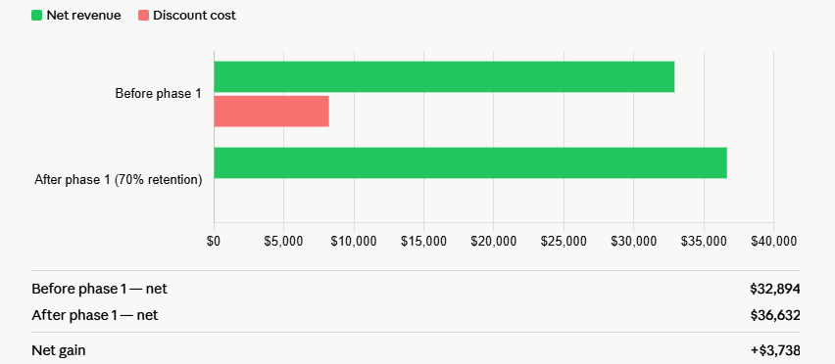

Conclusion :
If 70% of Promo Hunters are retained at full price post-sunset, the brand recovers $8,222 in discount savings against a net revenue reduction of approximately $4,484 which results in a net positive of $3,738 in the first phase alone.

8.2 | RECOMMENDATION - 02 : REDUCE Discounts for At-Risk Customers ( Gradually )
At-Risk Customers are the brand's largest segment at 1,899 customers and its biggest absolute margin drain at $11,219 annually. However unlike Promo Hunters, this segment is not uniformly discount dependent. 57.7% of At-Risk customers (1,096) people already buy without discounts. Only 42.3% which is approximately 803 customers are genuinely promo-dependent.

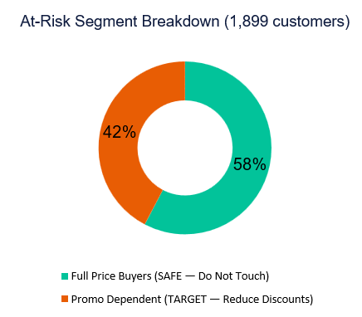
A full stop on discounts for this segment overnight would risk losing nearly 1,900 customers in a single action. A gradual, targeted reduction is the only responsible approach.

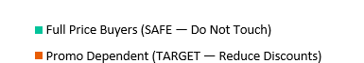

Trigger Behavior :Customers with more than three promotional purchases in their last ten transactions. This isolates the promo-dependent sub-group of approximately 803 customers without affecting the 57.7% who already buy at full price.

Action :
Month 3-4 : Reduce discount depth from 20% to 10% for the promo-dependent sub-group only.

Month 4-5 : Introduce a full-price loyalty rewards program, points accumulated for every full-price
purchase, redeemable for early access and priority service.

Month 5 : Evaluate results. If 40% or more of the sub-group is purchasing at full price, expand the
rollout. If below 30%, slow down the reduction pace.

Metric to Track: Repeat purchase rate without a discount. Target is 40% of the sub-group buying at full price by the end of Month 5.
Trade-Off: Risk of losing approximately 400 customers from the promo-dependent sub-group, representing $24,400 in potential revenue.

Conclusion :
$5,600 in discount savings combined with retained full-price buyers makes this net positive over a six-month horizon.

8.3 | RECOMMENDATION - 03 : PROTECT Organic Loyalists and High-Value Retainers  ( Never Discount )
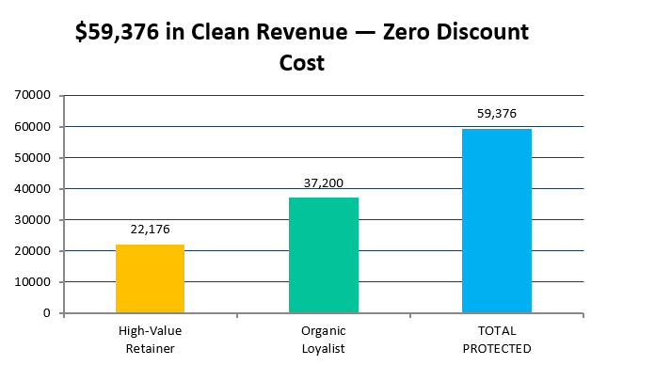
Organic Loyalists (600 customers) and High-Value Retainers (288 customers) together represent 888 customers who generate $59,376 in clean, full-price revenue with zero discount cost. They are the brand's most valuable asset and must be protected from discount campaigns under all circumstances.

Insight : Discounting these customers would be the single most damaging mistake the brand could make. A customer who currently pays full price and receives a discount learns to wait for discounts. Over time, this converts Organic Loyalists into Promo Hunters destroying the only genuine loyalty the brand has built.

Action :
Add Organic Loyalists and High-Value Retainers to a permanent exclusion list in the CRM system immediately. No discount codes, no promotional emails, no sale notifications should reach these customers.

Replace discounts with exclusive non-monetary benefits:
- Early access to new collections before public launch.
- Personalised thank you notes with high-value orders.
- Priority customer service channel.
- Invite-only brand events and product previews.

Excluding Organic Loyalists from all sale notifications carries a subtle but real risk. If a loyal customer discovers a public sale they were not informed about, they may feel penalized for their loyalty rather than rewarded. Which could damage the relationship the brand has worked hard to build.

Mitigation :
The solution is not to include them in discount campaigns but to give them something BETTER before the sale goes public. For example: -
- Send Organic Loyalists early access to the collection at full price 48 hours before any sale begins
- Frame it as "You get first pick before the sale crowd"
This way they never feel left out, and the brand never trains them to wait for a discount.

Metric to Track : Retention rate must stay above 90%. Average spend must stay above $62. Average rating must stay above 4.0. Any decline in these metrics should trigger an immediate review of the segment's experience.

Trade-Off : There is no short-term revenue trade-off. The long-term risk is brand perception that if the exclusion list is not maintained rigorously and these customers accidentally receive a discount, the habit formation risk is significant and very difficult to reverse.

8.4 | RECOMMENDATION - 04 : ACQUIRE More Ideal Customers ( Target the Right Profile )
The brand's ideal customer is aged 36–50, located in Alaska, Alabama, or Georgia, the three states with the highest concentration of Organic Loyalists relative to their customer base (23.6%, 22.5%, and 21.5% respectively). They shop primarily for Clothing and Accessories in Winter and Fall, pay full price every time, and rate the brand 4.38 out of 5.

WHERE TO FIND THEM:
- Priority 1 - Alaska: Highest organic loyalist concentration (23.6%) AND highest avg spend ($67.60). The strongest overall combination of loyalty density and customer value.

- Priority 2 - Alabama & Georgia: Organic loyalist rates above 21% with avg spend ~$59 and strong loyalty density, slightly more price-sensitive than Alaska.

- Priority 3 - Kansas (Different Profile): Lowest promo rate in the entire dataset (23.8%) which means customers here are the LEAST discount-dependent, even though current loyalist concentration (19%) and avg spend ($54.56) are lower. This signals an untapped market in which customers who already don't expect discounts, but haven't yet been converted into high-spend
loyalists. A brand led (non-discount) campaign here has high potential to convert.

- Priority 4 - Montana & Michigan : These states have good potential to reach Priority 2 levels with relatively limited incremental effort, given their organic loyalist rates of 19–21% and average spend of approximately ~$61.

- Watch - Pennsylvania & Connecticut : Near misses on Organic Demand classification (loyalist lift 1.23 and 1.17 respectively) are worth monitoring as the next tier of opportunity.

- Avoid - Indiana, Missouri, West Virginia, Oregon : Discount-driven states with below average loyalty. West Virginia is notable with a high spend of $63.88 but still discount-dependent, meaning acquisition here risks attracting high-spend Promo Hunters.

WHO TO TARGET :
- Female customers with 1.65x loyalist lift, the single strongest predictor of loyalty. Currently only 32% of the customer base. Acquisition campaigns should prioritize this segment.
- 36-50 age group is still the largest loyal segment by volume (172 organic loyalists).

WHAT TO FIX BEFORE ACQUIRING :
The subscription program (0.00 lift, 0% loyalty among 1,053 subscribers) must be redesigned around non-discount value (early access, styling perks, priority service) BEFORE any acquisition budget is spent promoting it. Acquiring more subscribers under the current program design would only grow a segment with zero loyalty.

WHAT TO SELL FIRST :
- Lead with Spring Footwear - lowest tenure (24.2), easiest entry point for new customers.
- Cross-sell into Winter Clothing - highest retention tenure (26.1).
- Best combination: Fall Clothing & Accessories - lowest promo rate (35.6%) among all season-category pairs.

PLAN OF ACTION :
- Lead acquisition campaigns with brand quality and the 4.38/5 rating (not discounts). This is the strongest message for Alaska, Alabama, Georgia, Montana & Michigan where customers already show high loyalty density.

- For Kansas, the message should be different, since customers here are already the least discount-dependent (23.8% promo rate), campaigns should focus on increasing engagement and basket size, not on "why not to use discounts." Highlight new collections, styling guides, and loyalty perks to convert low-promo browsers into high-spend regulars.

- Target the 36-50 age group and Female customer specifically across all six priority states.

- Do NOT run promo code acquisition campaigns in any of these states (every customer acquired via discount code is a potential Promo Hunter, regardless of geography).

9 | THE FULL PICTURE

If the brand executes all four recommendations over a 12-month horizon, the projected impact on key metrics is as follows:

Bringing all five key findings together, the brand's situation is clearer than it appeared at the start:

- 43% of customers are promo-dependent, and this rate doesn't improve even for the highest-value tier (Key Finding 2) discount dependency is a brand-wide issue, not a segment issue.

- Only 15.4% of customers (600) are genuinely loyal under Loyal_A, generating $59,376 in clean revenue alongside High-Value Retainers with zero discount cost (Key Findings 01 & 04).

- Geographically, loyalty is concentrated in just 8 "Organic Demand" states (616 customers), led decisively by Alaska. Most of the country (38 states, 2,969 customers) is Mixed with neither a strong opportunity nor a clear risk (Key Finding 03).

- The strongest predictors of loyalty aren't where you'd expect. Category, payment method, and shipping type show no signal (lift 0.90-1.13). Gender (Female, 1.65x lift) and subscription status (non-subscribers, 1.37x lift vs. 0.00x for subscribers) are the only two attributes with real predictive power (Key Finding 05).

- The subscription program, meant to be a loyalty driver , has a 0% loyalty rate among its 1,053 members. This is the single most actionable finding in the report: a structural fix, not a targeting fix.

THE PATH FORWARD

- Recommendation 01
(Stop Promo Hunters - Immediately) Removes 846 customers with 100% promo dependency from all discount campaigns. Recovers $8,222 in discount cost, with a projected net gain of $3,738 even after accounting for a conservative 30% revenue dip from this segment.

- Recommendation 02
(Reduce At-Risk Discounts -Gradually) Targets the 803 promo-dependent customers within the 1,899-strong At-Risk segment (42.3% of it), reducing discount depth from 20% to 10% over Months 3-5 while introducing a full-price loyalty rewards program. Projected net gain of $5,600 over six months, without disrupting the 57.7% of At-Risk customers who already buy at full price.

- Recommendation 03
(Protect Organic Loyalists & High-Value Retainers - Never Discount) Safeguards the $59,376 in clean, full-price revenue from 888 customers by permanently excluding them from all discount campaigns and replacing offers with non-monetary perks.

- Recommendation 04
(Acquire the Right Customers) Redirects acquisition spend toward Alaska and Kansas, prioritizes female customers (1.65x loyalty lift), and most critically puts fixing the broken subscription program (0% loyalty among 1,053 members) ahead of any new acquisition spend. Combined, Recommendations 01 and 02 alone recover an estimated $9,338 in the first six months, directly addressing the largest portion of the $19,882 annual discount leak.

TARGETS FOR NEXT 6-12 MONTHS:

Metric | Current | Target
Promo dependency (overall) | 43% | < 35%
Genuine loyalty rate (Loyal_A) | 5.4% | > 18%
Subscription loyalist rate | 0.0% | > 10%
Total discount cost (annual) | $19,882 | < $14,000
Female customer share | 32% | > 38%

